1. 
2. 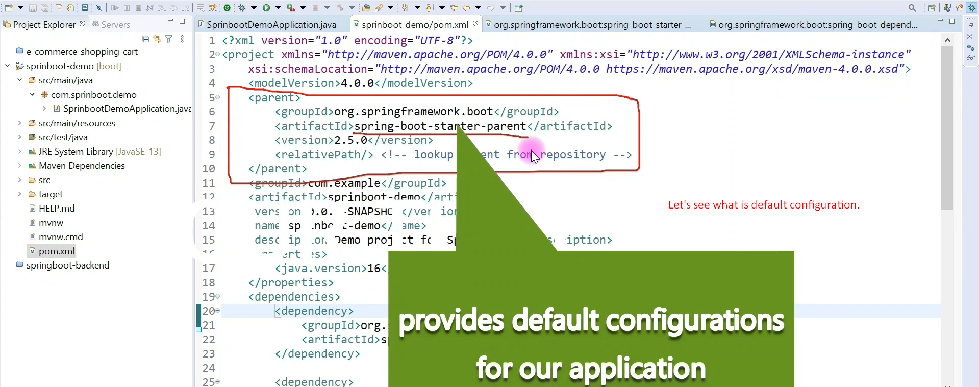
3. 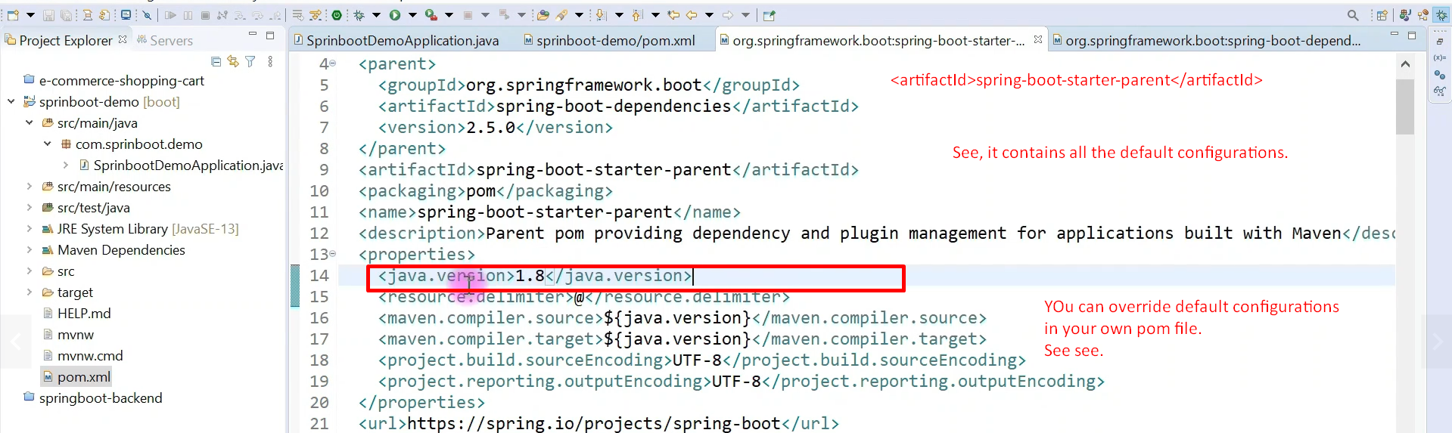
4. 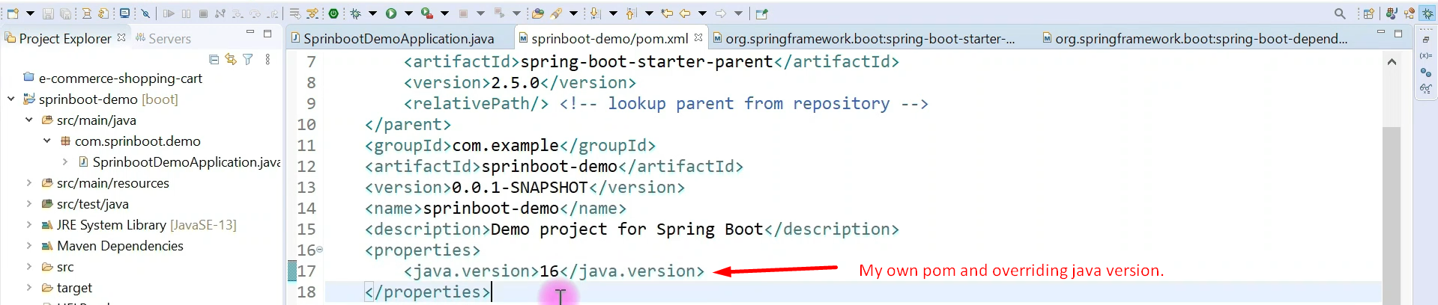
5. 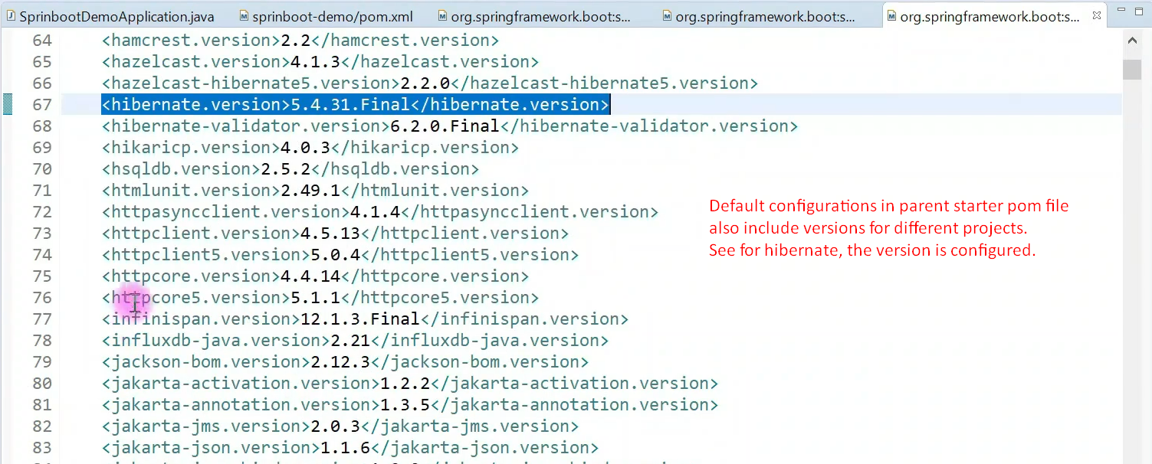Default Configurations:
   1. java version.
   2. A lot of maven plug-ins.
   3. Dependencies’ versions.
6. 